|  |  |  |
| --- | --- | --- |
| Catalog of products | IDC connector (Horn/Simple cow) |  |
| Connector Type | Jane Taurus |  |
| Spacing | 2mm |  |
| Number of rows | 2 |  |
| Line spacing | 2mm |  |
| Form of encapsulation | Straight in line |  |
| Contact material | Brass |  |
| Contact coating | Gold |  |

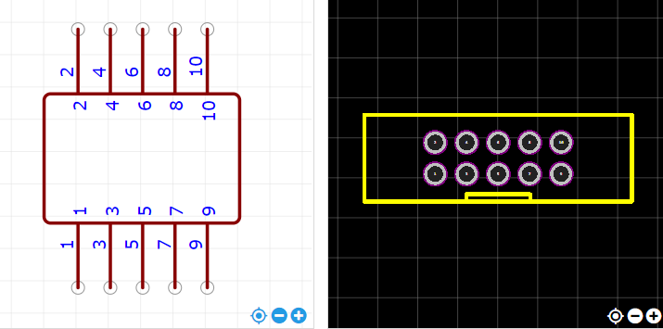

<https://item.szlcsc.com/221677.html>